Unit 1.overview of graphics systems:-
Video Display devices, Refresh cathode ray tubes, Raster-Scan and random scan display, Colour CRT Monitor, Direct View Storage tubes, Random Scan System.
The term of Graphics comes from Greek “graphikos” which means 'something written' e.g. autograph. So, Graphics are visual images or designs on some surface, such as a wall, canvas, screen, paper, or stone to inform, illustrate, or entertain.
The term computer graphics includes almost everything on computers that is not text or sound. Computer graphics can be a series of images which most often called video or a single image. The definition of computer graphics is the technology that deals with designs and pictures on computers. So, computer graphics are visual representations of data displayed on a monitor made on a computer.
Graphics is the pictorial representation of real world objects, data, statistical data etc.

Computer graphics is an art of drawing pictures, lines, charts, etc using computers with the help of programming. Computer graphics is made up of number of pixels. Pixel is the smallest graphical picture or unit represented on the computer screen. It involves computations, creation, and manipulation of data. In other words, we can say that computer graphics is a rendering tool for the generation and manipulation of images.

Basically there are two types of computer graphics namely.
Interactive/Active/online Computer Graphics:- (Active) Interactive Computer Graphics involves a two way communication between computer and user. Here the observer is given some control over the image by providing him with an input device for example the video game controller of the ping pong game. This helps him to signal his request to the computer.
Interactive computer graphics affects our lives in a number of indirect ways. For example, it helps to train the pilots of our airplanes.
i.e-person interacts with it.
e.g-Games, Chatting
GPS In OLA Cab.
Non Interactive/passive/offline Computer Graphics:- (Passive)
In non interactive computer graphics otherwise known as passive computer graphics. it is the computer graphics in which user does not have any kind of control over the image. Image is merely the product of static stored program and will work according to the instructions given in the program linearly. The image is totally under the control of program instructions not under the user.
i.e. Person is not involved
E.g: screen savers, Movies,TVs.etc
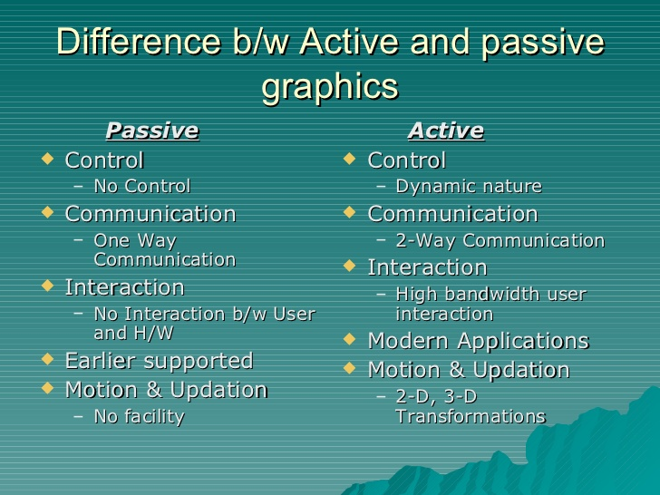
The main advantages of computer graphics are as follows:-
1. With the help of computer graphics user can communicate with the computer in most natural way and efficient manner.
2. It is possible to produce moving picture (animation) with the help of graphics.
3. User can control the animation by adjusting.
4. Graphics objects can be update dynamically i.e. we can change shape, colour, size of the object which is being viewed.
5. With the help of computer graphics one can embed audio, video in interactive graphics and generate audio, video feedback.
6. It have ability to show moving pictures and thus it is possible to produce animations with computer graphics.
7. With computer graphics user can also control the animation speed, portion of the view, the geometric relationship of the object in the scene to one another, the amount of detail shown and on.

Application of computer graphics or Use of computer graphics:-
- Presentation Graphics
- Computer Art
- Entertainment
- Visualization
- Image Processing
1. User interface:- it is now well established fact that graphical interface provide an attractive and easy interaction between users and computer. The built in graphics provide a graphical interface for user. User to interact with computer only by mouse clicking. Typing is necessary only to input text to be stored and manipulated.
2. Plotting of graphs and chart: - In industry, business, government and educational organization computer graphics is most commonly used to create 2D and 3D graphs mathematical. Physical and economics function is form of histogram bars and pie charts. These graphs and charts are very useful for decision making.
3. Computer aided drafting and design:- the computer aided drafting uses graphics to design components and system electrical, mathematical, electromechanical and electronic device such as automobile bodies, structure of building , air plane, ships, very large scale integrated chips and computer networks.
4. Simulation and Animation :- Use of graphics in simulation makes mathematical model and mechanical systems more realistic and easy to study. The interactive graphics supported by animation software proved these use in production of animation movies and cartoon films.

Characteristics of computer Graphics:-
- It has to be interactive.
- It has to be user friendly.
- Dynamics.
a. Motion dynamics: Deals with how the objects going to move.
b. Update dynamics: deals with what ^{changes} the object is going to undergo.
- Animations

Hardware Requirement for computer graphics:-
- Input Devices
- output Devices
- Display Devices
Input Devices:-
- Keyboard
- Mouse
- Joystic
- Spaceball,Trackball
- Data glove
- Digitizers
- Image Scanner
- Touch Panel
- Light Pen
- Voice System
Output Devices:-
- Monitor
- Printers
- Plotters

Display Devices:-
- Color CRT Monitor
- Direct view storage tube
- Plasma panel (flat panel, Flatron)
- LCD display (Liquid crystal display) e.g: Laptop,Mobile etc.

Software requirement for computer graphics:-
- O.S
- Graphics Software
- Language
. C (Borland or Turbo)
. C++ (Borland or Turbo)
. java etc
- Package
. Autocad
. Coraldraw
. STADDPRO(for civil engineering)
Etc.
Points:-
- Any object can be represented by specifying its position which is given by its co-ordinate i.e.(x,y) points.
Pixel:-
- Each screen point is referred to as a pixel or pel which stands for picture element.
Resolution:-
The maximum number of points /characters that can be displayed without overlap on the screen is referred to as the resolution.
- Text mode: - 80 Columns x Rows 25

We can have a graph here but graph will be simple one and will not be smooth.
- Graphics Mode:- 640 x 480
CGA (Color Graphics Adapter)
EGA (Enhanced Graphics Adapter)
VGA(Video Graphics Array)
SVGA(Super VGA)
What is a refresh rate and why is a monitor's refresh rate important?
An image appears on screen when electron beams strike the surface of the screen in a zig-zag pattern. A refresh rate is the number of times a screen is redrawn in one second and is measured in Hertz (Hz). Therefore, a monitor with a refresh rate of 85 Hz is redrawn 85 times per second. A monitor should be "flicker-free meaning that the image is redrawn quickly enough so that the user cannot detect flicker. Today, a refresh rate of 75 Hz or above is considered to be flicker-free.

Video Display Devices:-
The primary output device in a graphical system is the video monitor. The display devices developed in the mid-sixties and in common use until the mid-eighties are called Vector, Stroke, Line Drawing or Calligraphic displays. The term vector is used as a synonym for line here; a Stroke is a short line, and characters are made of sequences of such stroke. The operation of most video monitor is based on the standard Cathode Ray Tube (CRT) design but several other technologies exist.
A cathode ray tube (CRT) is a specialized vacuum tube in which images are produced when an electron beam strikes a phosphorescent surface. Most desktop computer displays make use of CRTs. The CRT in a computer display is similar to the "picture tube" in a television receiver.
Such as …..(see from book)

The main element of a video monitor is the CRT.
The operation of CRT is very simple –
- The electron gun emits a beam of electrons cathode rays.
- The electron beam passes through Focusing and Deflection system that direct it towards specified position on the phosphor-Coated Screen.
- When the beam hits the screen, the phosphor emits a small spot of light at each position contacted by the electron beam.
- It redraws the picture by directing the electron beam back over the same screen points quickly.
- There are two ways by which we can display an object on the screen
- Raster Scan and
- Random Scan.
Refresh CRT
Output Devices

VDU/Monitor Printer Plotter
- Primary output device in a graphics system is a video monitor.
- VDU operation based on CRT.
VDU

Emmissive Non-Emmissive

CRT LED Plasma
Panel
All CRTs have three main elements:
An electron gun
A deflection system and
A screen.
The electron gun provides an electron beam which is a highly concentrated stream of electrons.
The deflection system positions the electron beam on the screen.
And the screen displays a small spot of light at the Point where the electron beam strikes it.
Refresh CRT: A beam of electrons (Cathode Rays) emitted by an electron gun passes through focusing and deflection systems that direct the beam towards specified position on the Phosphor- Coated screen. The phosphor then emits a small spot of light at each position contacted by the electron beam. Because the light emitted by the phosphor fades very rapidly, some method is needed for maintaining the screen picture. One way to keep the phosphor glowing is to redraw the picture repeatedly by quickly directing the electron beam back over the same points. This type of display is called
a refresh CRT.

The basic operation of CRT is showing in this figure.

See copy
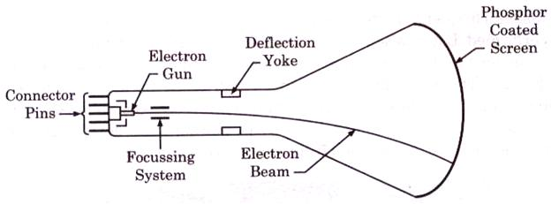

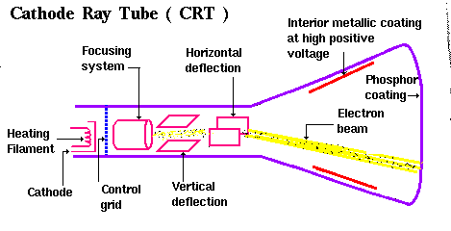

- Electron gun: The primary components of an electron gun in CRT are the heated metal cathode and control grid. Heat is supplied to the cathode by directing a current through a coil of wire called the filament, inside the cylindrical cathode structure. This cause electrons to be “boiled of” the cathode surface. In the vaccum inside the CRT envelope, the free negatively charged electrons are then accelerated toward the phosphor coating by a high positive voltage. The accelerating voltage can be generated with a positively charged metal coating on the inside of the CRT envelope near the phosphor screen, or an accelerating anode can be used.
Component of electron gun:-
Heated Metal Cathode
Heating Filament
Control Grid
Heat is supplied by directing a current through a coil of wire called filament.
- Intensity:- Intensity of the electron beam is controlled by setting voltage levels on the control grid, which is a metal cylinder that fits over the cathode. A high –Ve voltage is applied to the control grid will shut off the beam by repelling electrons and stopping them from passing through the small hole at the end of the control grid structure.
A smaller –Ve voltage on the control grid simply decreases the number of electrons passing through, since the amount of light emitted by the phosphor coating depends on the number of electrons striking the screen, we control the brightness of a display by varying the voltage on the control grid.

- Focusing System:-
Three types of focusing system
1.Electrostatic :- used in T.V monitor
2.Electro magnetic
3.Magnectic Field
The focusing system is used to create a clear picture by focusing the electrons into a narrow beam. The focusing system in a CRT is needed to force the electron beam to converge into a small spot as it strikes the phosphor. Otherwise the electrons would repel each other and the beam would spread out as it approaches the screen.
Deflection system:-
Two types of deflection system
1. Horizontal Deflection system-accomplished with one pair of coil.
2. Vertical Deflection system- accomplished with other pair of coil.
Deflection of the electron beam can be controlled by either electric fields or magnetic fields. In case of magnetic field, two pairs of coil are used, one for horizontal deflection and other for vertical deflection.
In case of electric field, two pairs of parallel plates are used, one for horizontal deflection and second for vertical deflection.
Figure given
Persistence - it is defined as the time they continue to emit light after the CRT beam is removed. Persistence is defined as the time it takes the emitted light from the screen to decay to one tenth of its original intensity. Lower persistence phosphors require higher refresh rates to maintain a picture on the screen without flicker. A phosphors with low persistence is useful for animation. A high persistence phosphor is useful useful for displaying highly complex, static pictures. Although some phosphor have a persistence greater than 1 second, graphics monitor are usually constructed with a persistence in the range from 10 to 60 microseconds.
Resolution:- the number of points per centimetre that can be used to plotted horizontally and vertically. Or total number of points in each direction.
The maximum number of points that can be displayed without overlap on CRT is called resolution.
Two types of resolution
1.Image resolution(spacing) distance from one pixel to next pixel is called image resolution (spacing)
2. Screen resolution: the number of pixel in the horizontal and vertical direction.
The resolution of a CRT is depend
Type of phosphor
Intensity to be displayed
Focusing and deflection system
Aspect ratio:- it is the ratio of vertical to horizontal points necessary to produce equal lengh in line in both directions on the screen.
Aspect ratio= V/H
Example – an aspect ratio of ¾ means that a vertical line plotted with three points has same length as horizontal line plotted with four point.
Frame buffer:- the memory wherein the picture definition is stored is known as frame buffer (refresh buffer)

CRT screen:- The inside of large end of a CRT is coated with a fluorescent material that gives off light when struck by electrons. After a short time the excited electrons come back to their ground state. During this period we see a glowing spot that quickly fades after all excited electrons are returned to their ground state.
There are two ways by which we can display an object on the screen
- Raster –Scan Display
- Random –Scan Display

- Raster –Scan display:- it is based on television technology. In a Raster –Scan system the electron beam is swept across the screen, one row at a time from top to bottom. As the electron beam moves across each row, the beam intensity is turned on and off to create a pattern of illuminated spots. Picture definition is stored in a memory are called the refresh buffer or frame buffer. This memory area holds the set of intensity values for all the screen points. Stored intensity values are then retrieved from the refresh buffer and “painted” on the screen one row (Scan line) at a time. Each screen point is referred as pixel or pel. Shortened form of picture element. At the end of each scan line the electron beam returns to the left side of the screen to begin displaying the next scan line. And at the end it returns to top left corner
- of the screen. And so on.
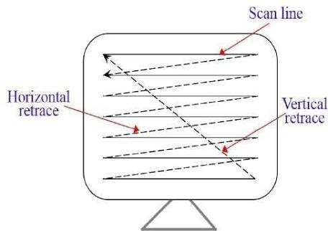
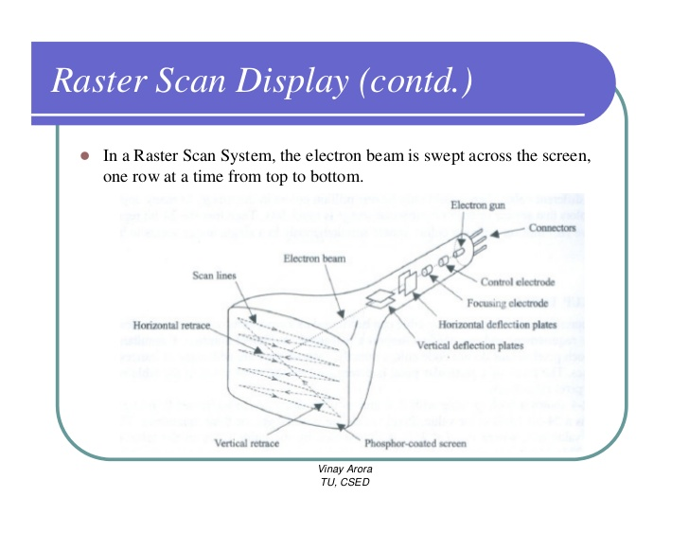

Printers are also the example of Raster –Scan system.
Note:- on a black and white system with one bit per pixel, the frame buffer is commonly called a bitmap.
Bitmap:-
A Bitmap is a ones and zeros representation of the rectangular array of points (pixel or points short form of “picture element”) on the screen.
Systems with multiple bits per pixel, the frame buffer is often referred to as a pixmap.

- Random –scan display:- in this technique the electron beam is directed only to the part of screen where the picture is to be drawn rather than scanning from left to right and top to bottom as in raster scan. It is also called vector display, stroke- writing display or Calligraphic display.
Picture difinition is now stored as a set of line drawing commands in an area of memory reffered to as the refresh display file. Some times the refresh display file is called the display list, display program or simplay the refresh buffer.
To display a specified picture, the system cycles through the set of commands in display file, drawing each component line in turn. All the line drawing command are processed, the system cycles back to the first line command in the list. Random- scan displays are designed to draw all the component lines of picture 30 to 60 times each second.
Random scan monitors draw a picture one line at a time and for this reason are reffered to as vector.

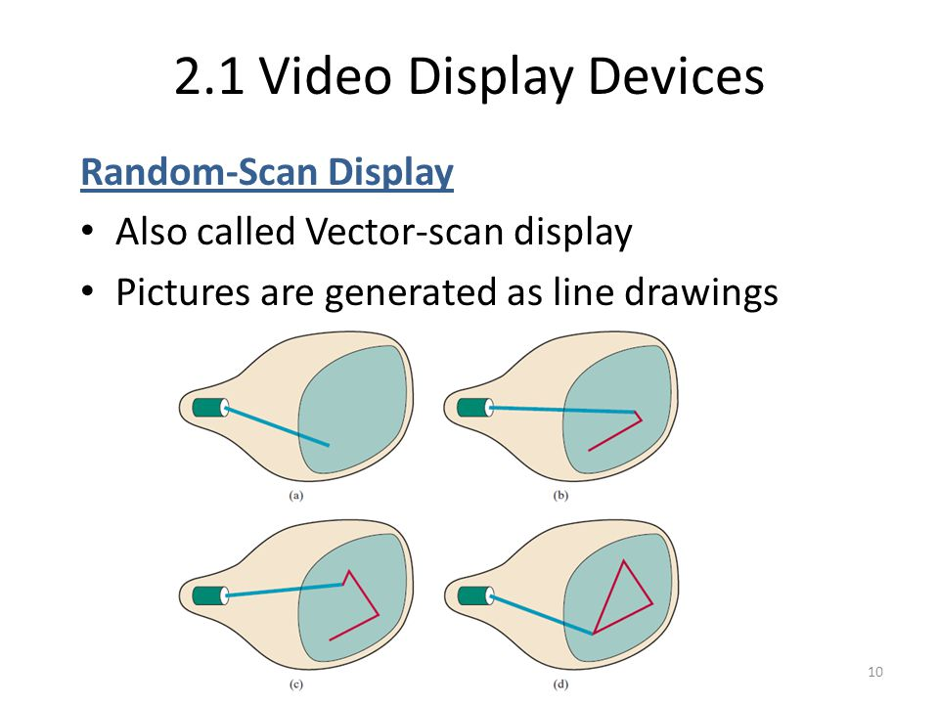
Advantages
Best suited for line drawing application
Higher resolution than raster.

Difference between Raster and Random Scan display?
Sl.No.base of difference | Raster Scan Display | Random Scan Display
- Electron Beam | In this, the electron beam is swept across the screen, one row at a time from top to bottom. | In this, the electron beam is directed only to the parts of the screen where a picture is to be drawn.
2.picture draw | The pattern is created by illuminated spots. | Here a picture is drawn one line at a time.
3.refreshing rate | Refreshing on raster scan display is carried out at the rate of 60 to 80 frames per second. | Refreshing rates are greater than 60 frames for small set of lines. Refresh rates depend on the number of lines to be displayed.
4.line draw | This display produces smooth line drawing as the CRT beam directly follows the line path. | This display produces jagged lines that are plotted as discrete point sets.
5.Resolution | This produces higher resolution. | This provides lower resolution.
6.Draw an image | Screen points/pixel are used to draw an image. | Mathematical function are used to draw an image.
7. Picture definition | Picture definition is stored as a set of intensity values for all screen points, called pixels in refresh buffer area. | Picture definition is stored as a set of line drawing instruction in a display file.

